DSC 550 Term Project: Predicting Wildfire Containment Time and Estimating Property Value Exposure in California

Zicheng (Chance) Xu

March 1, 2025

Introduction
Wildfires in California have become a headline-grabbing crisis, scorching landscapes, displacing families, and torching homes with alarming frequency. Even though I don’t live there, the news footage of smoke-choked skies and the stories of devastated communities hit hard—California’s plight is impossible to ignore. These fires don’t just threaten lives; they hammer the economy, leaving homeowners, insurance companies, real estate investors, and local governments grappling with the fallout. My project dives into two big questions: How long does it take to contain a wildfire, and what’s the potential property value at stake when flames roar through? Hopefully these aren’t abstract puzzles—they’re practical tools with real-world punch.
For homeowners, predicting containment time could mean the difference between a chaotic evacuation and a well-planned exit. Insurance companies could sharpen their risk models, adjusting premiums to match the threat. Investors might rethink pouring cash into fire-prone zones if they knew the baseline values at risk, and policymakers could deploy firefighting crews more strategically or tweak zoning laws to curb future losses. If I were pitching this to stakeholders, I’d say: “Picture this—data-driven answers that cut through the smoke. We’re not guessing here; we’re using California’s own records to protect lives, save money, and guide decisions. Who wouldn’t want in on that?”
The data’s solid. For wildfires, I pulled historical records from CAL FIRE (2014–2017) via the Cornell Virtual Workshop, zeroing in on 2015–2017 for consistent date info. For property values, I tapped Zillow’s massive housing dataset, tracking home values over time and regions. Together, they offer a window into fire duration and economic exposure—perfect for digging into these dual challenges.

Milestone 1: Data Selection and EDA
I started with the wildfire data, an Excel file from CAL FIRE with tabs for 2014–2017. Each tab listed fields like AGENCY, CAUSE, GIS_ACRES, ALARM_DATE, and CONT_DATE, but a quick peek showed 2014 was missing key dates for my DURATION calculation (CONT_DATE - ALARM_DATE). So, I focused on 2015–2017, which shared core columns like YEAR, STATE, and UNIT_ID. Running a script, I found 7,354 duplicates across 23,595 rows—messy, but dropping them left me with a cleaner 16,241 records. However, that was not enough, as there are clear outliers such as record with negative containment duration or a duration of more than a few years per the [containment date – alarm date] formula. Removing outliers I found 4022 good records for the analysis and model building.
Below is a complete list of definitions of the data fields:

ITEM NAME | DATA | TYPEDESCRIPTION
YEAR_ | Text | Fire Year
STATE | Text | State
AGENCY | Text | Direct protection agency responsible for fire
UNIT_ID | Text | ICS code for unit
FIRE_NAME | Text | Name of the fire
INC_NUM | Text | Number assigned by the Emergency Command Center of the responsible agency for the fire
ALARM_DATE | Date | Alarm date for fire
CONT_DATE | Date | Containment date for fire
CAUSE | Integer | Reason fire ignited
COMMENTS | Text | Miscellaneous comments
REPORT_AC | Number | Estimated area consumed in fire
GIS_ACRES | Number | GIS calculated area in acres
C_METHOD | Integer | Method used to collect perimeter data
OBJECTIVE | Integer | Either suppression or resource benefit
FIRE_NUM | Text | --

EDA was eye-opening. A scatter plot of GIS_ACRES versus DURATION (Figure below) showed bigger fires often take longer to contain, though the spread hinted at other influences—like weather or crew size—lurking beneath.
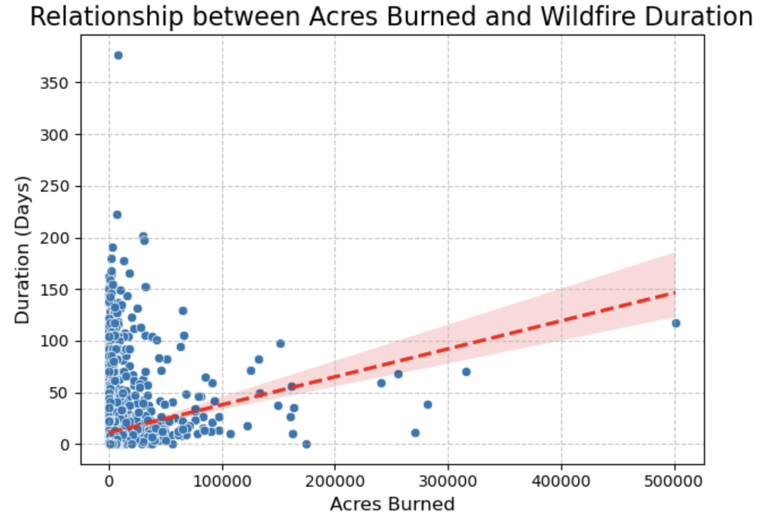
Bar charts of Cause (First figure below) vs Average Duration of the fire spotlighted frequent culprits: “Lightning,” “Unknown/Unidentified,” and “Equipment Use.” The same goes to the Unit Place (Second figure below) vs Average Duration of the fire: “Rouge River – Siskiyou”, “Lassen Volcanic NP”, and “Yosemite National Park.” It got me thinking—could these patterns predict containment time? The Zillow data was a beast—nearly 8 million rows after pivoting into row based from time series (for analysis and model building). I plotted average housing value over time in Los Angeles(Third figure below), and its sky-high recent values stood out following the steady climbs over the years after the dip around early 2007 until around 2012, the period within which there was economic crisis, and screaming economic risk when fires hit the region .

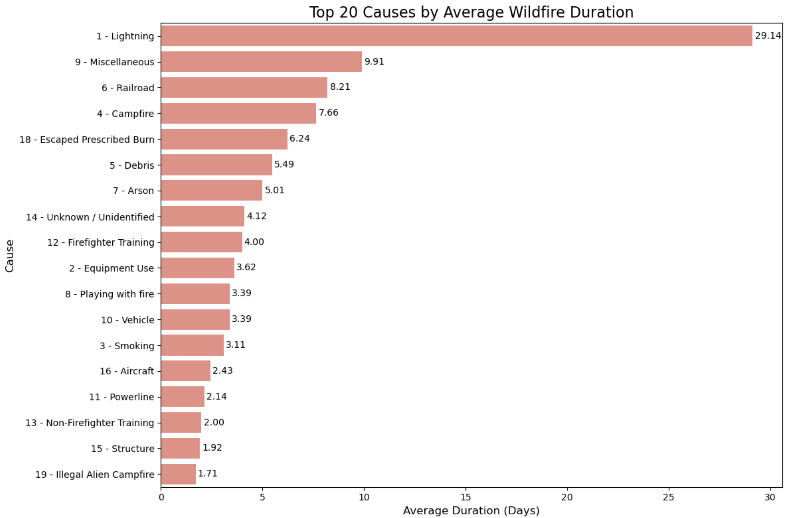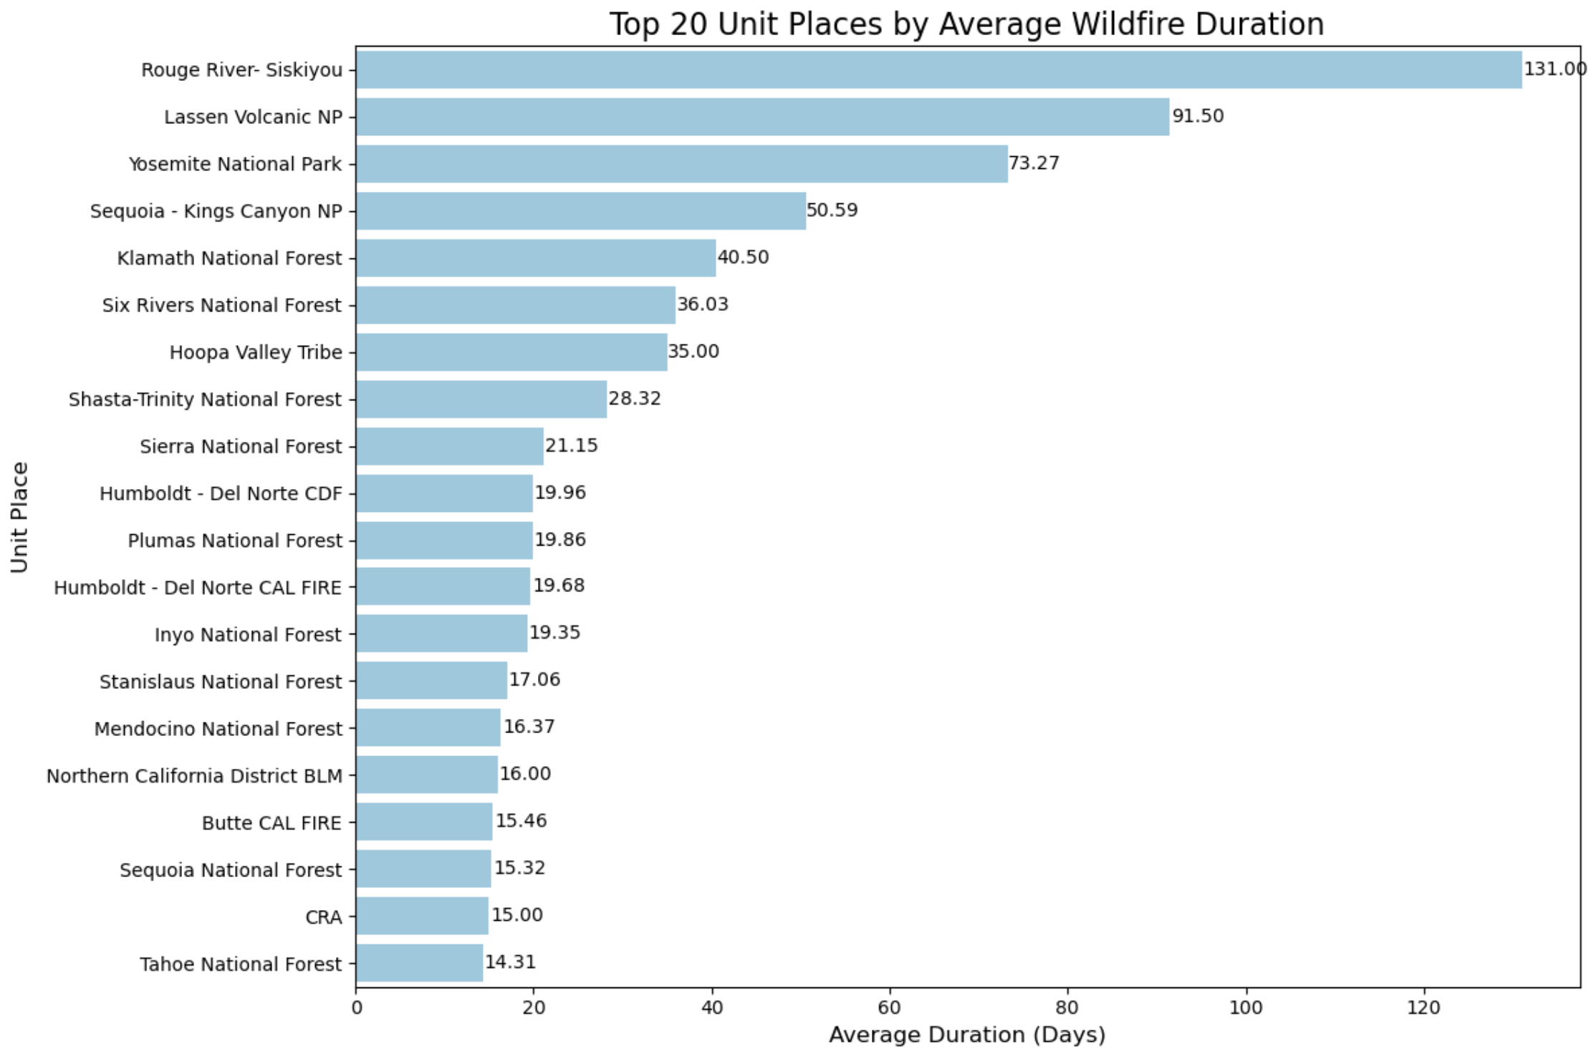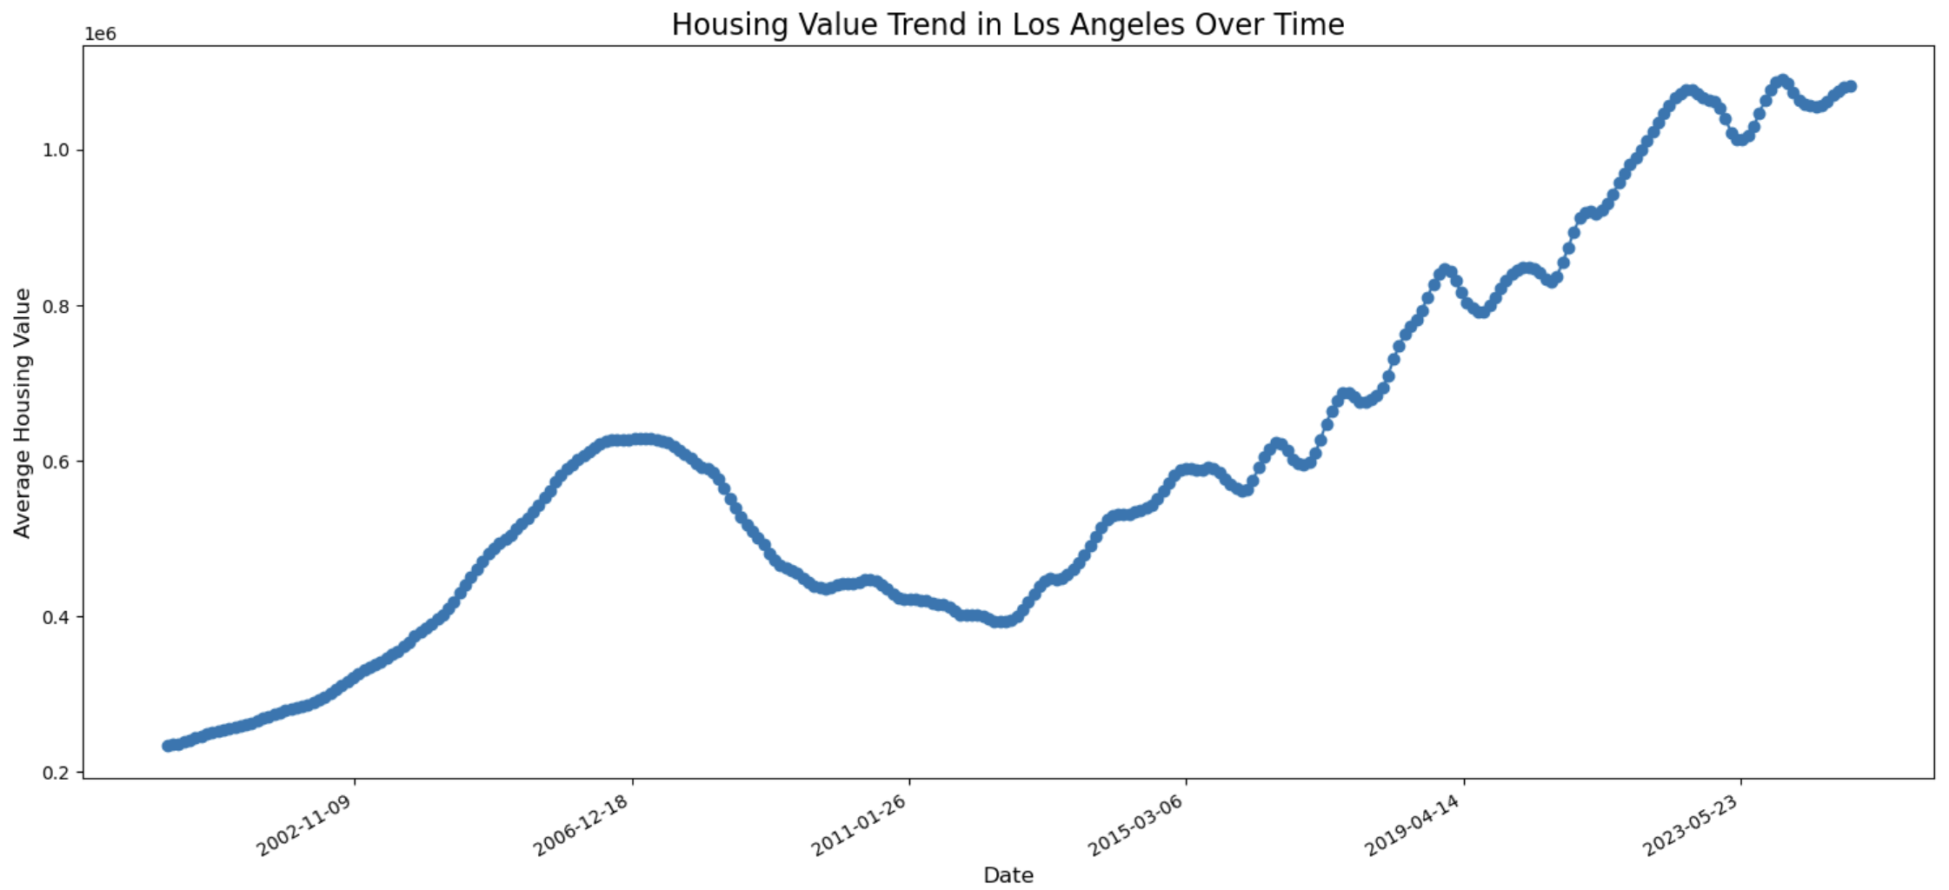

Milestone 2: Data Preparation
Cleaning the wildfire data took some elbow grease. I removed STATE(99% of the data is “California”, thus kept all records where STATE = “California”), Fire Name(Not insightful), Incident Number(ID, not insightful), REPORT_AC(More accurate data provided by the field GIS_ACRES), CONT_DATE(Avoid data leakage), Objective(Only two unique values with one of them not insightful at all).I standardized column names (YEAR_ to YEAR, ALARM_DATE_Con to ALARM_DATE) and turned dates into datetime format to compute DURATION. Categorical fields like AGENCY, UNIT_ID, and CAUSE had rare categories (<2 occurrences across train+test), which I mapped to “Other” to avoid clutter. Then, I one-hot encoded them with handle_unknown='ignore’, ensuring testing process and new 2025 categories wouldn’t trip up the model. I also extracted ALARM_MONTH and ALARM_DAY_OF_YEAR from ALARM_DATE for extra time-based predictors.
The Zillow data needed serious trimming. I ditched RegionID(ID, not insightful), RegionType (just “zip”), StateName (same as State field), and SizeRank (a dataset rank, not house size, thus not insightful). Null Housing Value rows (~1.9M) got the axe—imputing them felt like guessing twice—leaving 5.9 million. I dropped rows with null City or Metro (193K and 711K), reasoning that with 5.2 million left, I could afford it, and accurate imputation was tricky. I pulled Year, Month, and Day from RecordDate, dropping the original. High-cardinality fields (City, Metro, CountyName, >200 unique values) got label encoding; State (<200) got one-hot encoding to balance detail and dimensionality.

Milestone 3: Model Building and Evaluation
For wildfires, I split the data (75% train, 25% test) and ran SelectKBest with mutual information, landing on 10 features: AGENCY_California Department of Forestry and Fire Protection, AGENCY_National Park Service, AGENCY_USDA Forest Service, UNIT_ID_Sequoia - Kings Canyon NP, CAUSE_Lightning, CAUSE_Non-Firefighter Training, GIS_ACRES, YEAR, ALARM_MONTH, ALARM_DAY_OF_YEAR. I tested Random Forest and Linear Regression with these features and PCA (1–5 components). Random Forest with all 10 features shone: R2 = 0.5989, MSE = 334.3008, RMSE ≈ 18.28 days. PCA tanked it—1 component gave R2 = -0.1529 (Figure below: feature importance bar plot, GIS_ACRES tops the list).
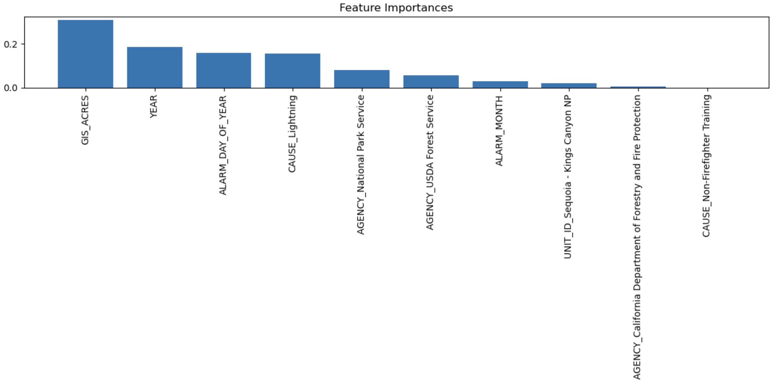
For Zillow, I used f_regression to pick 10 features from 57 post-encoding: State_CA, State_HI, State_IN, State_MA, State_NJ, State_OH, State_OK, RegionName, Metro, Year. Random Forest crushed it: R2 = 0.9977, MSE = 120,661,575, RMSE ≈ $10,984.60. PCA (95% variance = 1 component) dropped to R2 = 0.8065, MSE = 10,157,417,403, RMSE ≈ $100,783.75 (Figure below: PCA variance plot).
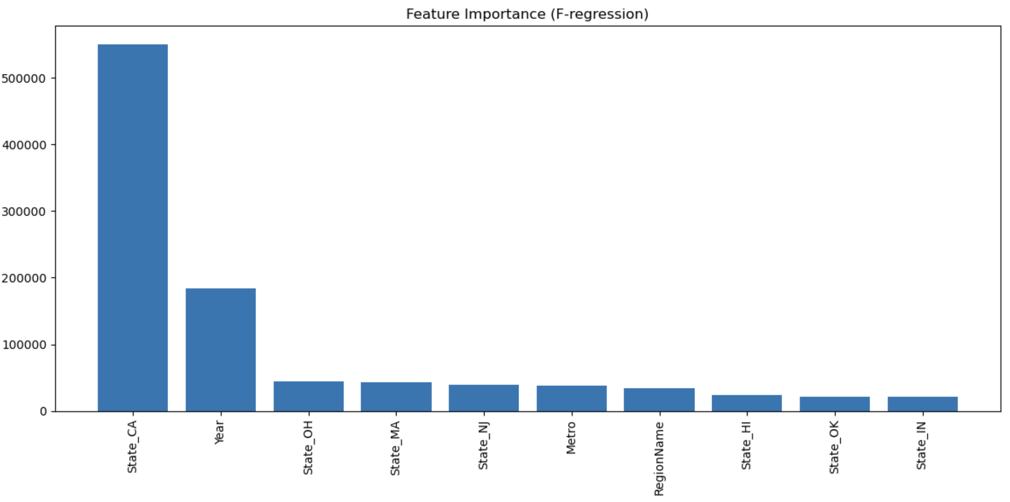
For 2025 wildfires, I applied the Random Forest to three fires by inputting related data for the fields found from Cal Fire 2025(DataFrame shown below):
- 23,707 acres: Actual = 44 days, Predicted = 86.41 days (Error: +42.41).
- 1,052 acres: Actual = 3 days, Predicted = 3.52 days (Error: +0.52).
- 799 acres: Actual = 8 days, Predicted = 3.28 days (Error: -4.72).
Metrics were rough: R2 = -0.8199, RMSE = 24.64 days—great for small fires, awful for big ones.
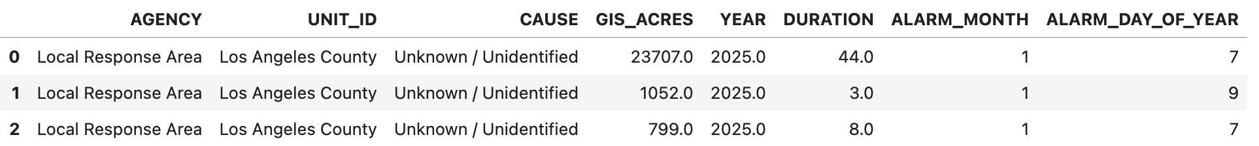

Conclusion

What the Analysis/Model Building Tells Me
The wildfire model does a solid job on historical data—explaining ~60% of DURATION variance with an 18-day error isn’t bad for a messy problem. GIS_ACRES is a heavy hitter, but the 2025 predictions reveal cracks: spot-on for small fires (errors <5 days), yet way off for the big one (44 vs. 86 days). It’s like the model memorized past patterns but stumbled on new ones. The housing model, though, is doing pretty good—99.8% of Housing Value variance with a $11,000 error is tight for real estate swings. Location (Region Name, Metro) and time (Year) drive its success.

Is This Model Ready to Deploy?
The housing model’s a green light—deploy it today for insurance pricing or investor dashboards. The wildfire model’s a yellow light. It’s handy for small fires, but the 2025 flop (R2 = -0.82) says it’s not ready for prime time, especially for large-scale disasters where precision saves lives and cash. Given the seriousness of the wildfire impact, we should be gathering more predictor variables that are helpful for the prediction if such data becomes available.

Recommendations
For wildfires, I’d hunt down post-2017 CAL FIRE data—2015–2017 might be stale. Toss in weather (wind, humidity) or crew data to balance GIS_ACRES’s dominance. Cross-validation could test if it holds up beyond my test set, and tweaking Random Forest parameters might squeeze out more juice. Save the model with joblib for quick pulls later. For housing, roll it out—link it to wildfire zones for a risk mashup. Maybe map fire-affected zip codes to Housing Value shifts if I can snag post-fire data.

Potential Challenges and Opportunities
Wildfires face data drift—2025 fires might differ in ways my predictors miss (new firefighting tech?). Zillow lacks post-fire value drops, so connecting fire impact to dollars needs more digging—maybe FEMA or local sales data? Opportunities are juicy: blend datasets for a fire-risk-to-value score, or try gradient boosting for wildfires to outdo Random Forest. This could grow into a full-on decision-support system, guiding everything from insurance quotes to evacuation plans.

